**Week 7 : Hands-On**

**ReactJS-HOL-9**

**LIstofPlayers.js**

import React from 'react';

const ListofPlayers = () => {

  const players = [

    { name: 'Virat', score: 95 },

    { name: 'Rohit', score: 85 },

    { name: 'Dhoni', score: 65 },

    { name: 'Rahul', score: 45 },

    { name: 'Pant', score: 60 },

    { name: 'Jadeja', score: 92 },

    { name: 'Bumrah', score: 78 },

    { name: 'Shami', score: 35 },

    { name: 'Ashwin', score: 58 },

    { name: 'Surya', score: 88 },

    { name: 'Gill', score: 49 }

  ];

  const lowScorers = players.filter(player => player.score < 70);

  return (

    <div>

      <h2>All Players:</h2>

      <ul>

        {players.map((p, index) => (

          <li key={index}>{p.name} - {p.score}</li>

        ))}

      </ul>

      <h3>List of Players with score below 70:</h3>

      <ul>

        {lowScorers.map((p, index) => (

          <li key={index}>{p.name} - {p.score}</li>

        ))}

      </ul>

    </div>

  );

};

export default ListofPlayers;

**IndianPlayers.js**

import React from 'react';

const IndianPlayers = () => {

  const T20Players = ['Virat', 'Rohit', 'Rahul', 'Pant'];

  const RanjiTrophyPlayers = ['Jaiswal', 'Sarfaraz', 'Shubman', 'Pujara'];

  const allPlayers = [...T20Players, ...RanjiTrophyPlayers];

  const oddPlayers = allPlayers.filter((_, index) => index % 2 !== 0);

  const evenPlayers = allPlayers.filter((_, index) => index % 2 === 0);

  return (

    <div>

      <h2>All Players (Merged):</h2>

      <ul>

        {allPlayers.map((player, index) => (

          <li key={index}>{player}</li>

        ))}

      </ul>

      <h3>Odd Team Players:</h3>

      <ul>

        {oddPlayers.map((player, index) => (

          <li key={index}>{player}</li>

        ))}

      </ul>

      <h3>Even Team Players:</h3>

      <ul>

        {evenPlayers.map((player, index) => (

          <li key={index}>{player}</li>

        ))}

      </ul>

    </div>

  );

};

export default IndianPlayers;

**App.js**

import React, { useState } from 'react';

import ListofPlayers from './ListofPlayers';

import IndianPlayers from './IndianPlayers';

function App() {

  const [flag, setFlag] = useState(true);

  return (

    <div style={{ padding: '20px' }}>

      <h1>Cricket App</h1>

      <button onClick={() => setFlag(!flag)}>

        Toggle Component

      </button>

      {flag ? <ListofPlayers /> : <IndianPlayers />}

    </div>

  );

}

export default App;

**Output:**

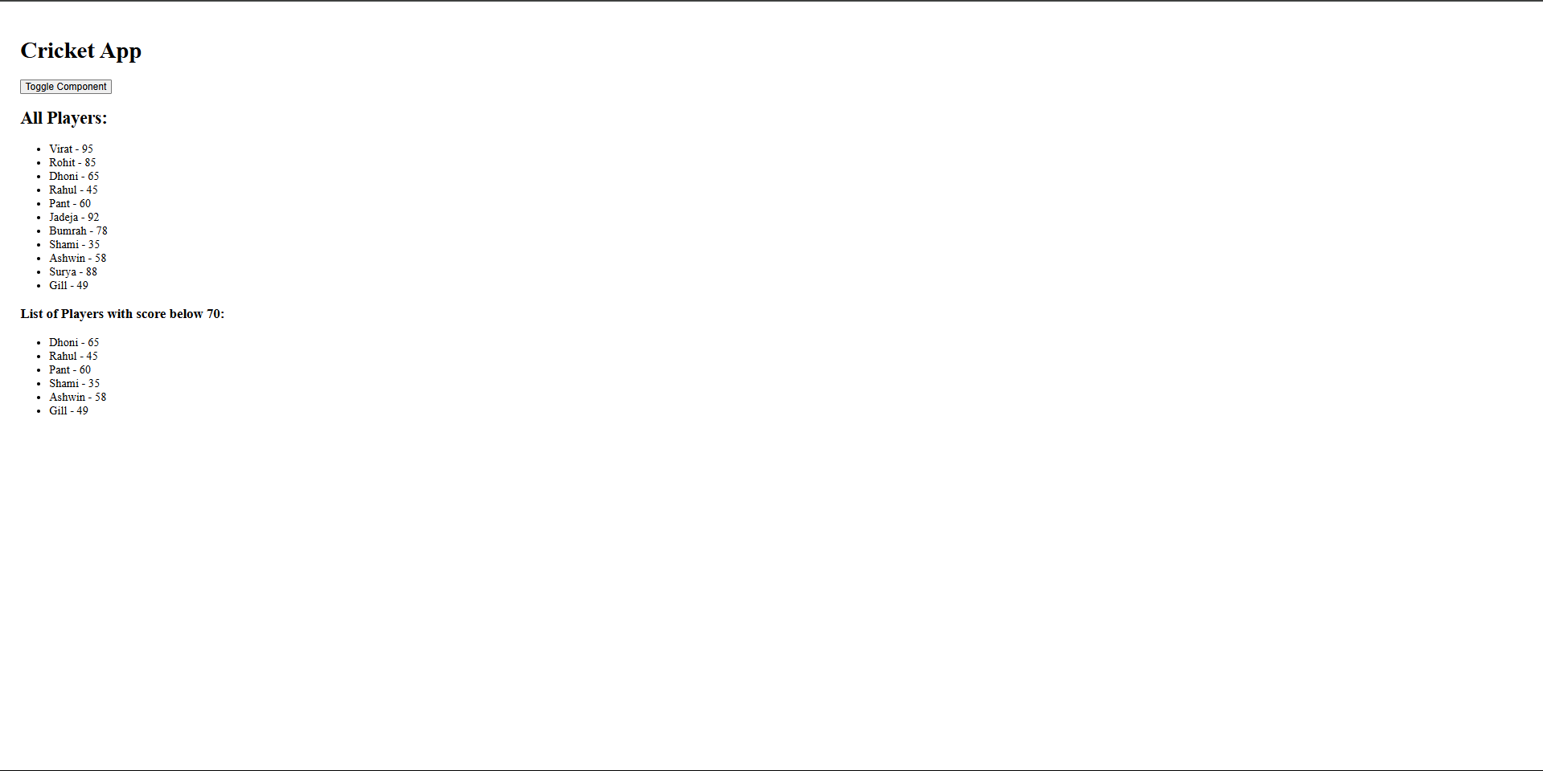

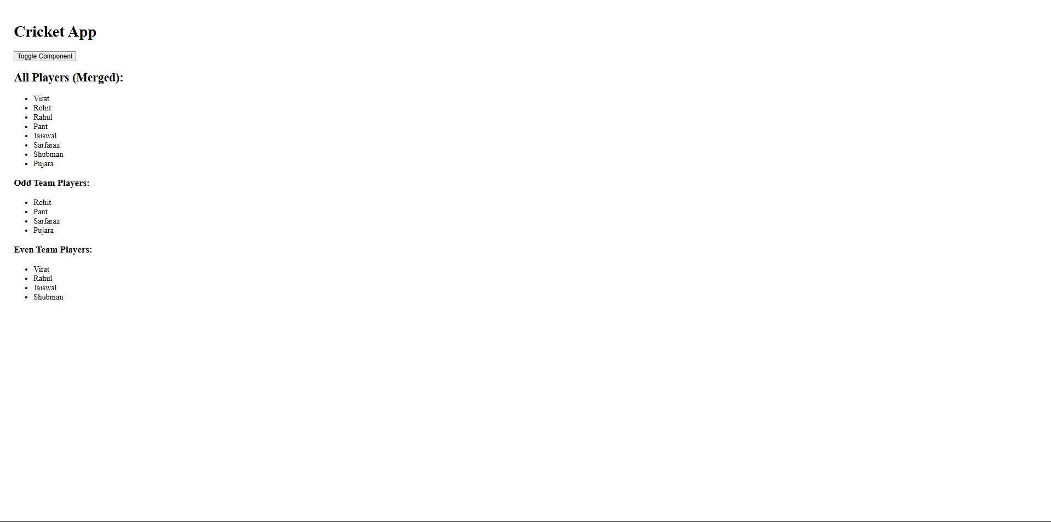

**ReactJS-HOL-10**

**App.js**

import React from 'react';

function SpaceRentalApp() {

  const heading = <h1>Office Space Rental Listings</h1>;

  const imageURL = "https://via.placeholder.com/400x200.png";

  const officeImage = <img src={imageURL} alt="Office Space" style={{ width: '400px', height: '200px' }} />;

  const office = {

    name: "Tech Park Workspace",

    rent: 75000,

    address: "123, IT Hub Road, Chennai"

  };

  const officeList = [

    { name: " Office A", rent: 55000, address: "Area A" },

    { name: " Office B", rent: 65000, address: "Area B" }

  ];

  const getRentStyle = (rent) => {

    return {

      color: rent > 60000 ? 'green' : 'red',

      fontWeight: 'bold'

    };

  };

  return (

    <div style={{ padding: '20px', fontFamily: 'Arial' }}>

      {heading}

      {officeImage}

      <h2>Featured Office</h2>

      <p><strong>Name:</strong> {office.name}</p>

      <p><strong>Rent:</strong> <span style={getRentStyle(office.rent)}>{office.rent}</span></p>

      <p><strong>Address:</strong> {office.address}</p>

      <h2>All Office Listings</h2>

      <ul>

        {officeList.map((item, index) => (

          <li key={index} style={{ marginBottom: '10px' }}>

            <strong>{item.name}</strong><br />

            Rent: <span style={getRentStyle(item.rent)}>{item.rent}</span><br />

            Address: {item.address}

          </li>

        ))}

      </ul>

    </div>

  );

}

export default App;

**Output:**

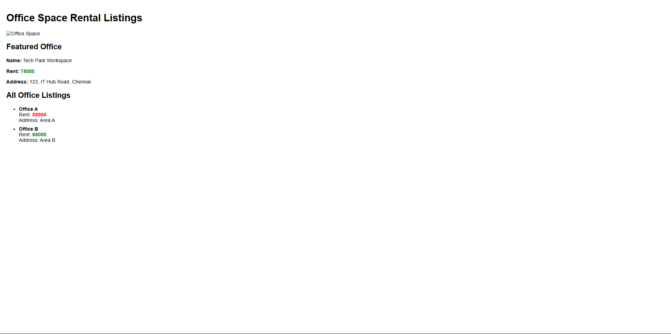

**ReacJS-HOL-11**

**App.js**

import React, { Component } from 'react';

import CurrencyConvertor from './CurrencyConvertor';

class App extends Component {

  constructor() {

    super();

    this.state = {

      count: 0

    };

  }

  increment = () => {

    this.setState({ count: this.state.count + 1 });

  };

  decrement = () => {

    this.setState({ count: this.state.count - 1 });

  };

  sayHello = () => {

    alert("Hello! User");

  };

  handleIncrement = () => {

    this.increment();

    this.sayHello();

  };

  sayWelcome = (message) => {

    alert(message);

  };

  handleClick = () => {

    alert("I was clicked");

  };

  render() {

    return (

      <div style={{ padding: '10px' }}>

        <p>{this.state.count}</p>

        <button onClick={this.handleIncrement}>Increment</button>

        <br /><br />

        <button onClick={this.decrement}>Decrement</button>

        <br /><br />

        <button onClick={() => this.sayWelcome("welcome")}>Say welcome</button>

        <br /><br />

        <button onClick={this.handleClick}>Click on me</button>

        <br /><br />

        <CurrencyConvertor />

      </div>

    );

  }

}

export default App;

**CurrencyConvertor.js**

import React, { Component } from 'react';

class CurrencyConvertor extends Component {

  constructor() {

    super();

    this.state = {

      amount: '',

      currency: ''

    };

  }

  handleChange = (e) => {

    this.setState({ amount: e.target.value });

  };

  handleSubmit = () => {

    let converted = (this.state.amount/101.01).toFixed(2);

    this.setState({ currency: converted });

  };

  render() {

    return (

      <div>

        <h2 style={{ color: 'green' }}>Currency Convertor!!!</h2>

        <label>Amount:</label><br />

        <input

          type="text"

          value={this.state.amount}

          onChange={this.handleChange}

        /><br /><br />

        <label>Currency:</label><br />

        <input

          type="text"

          value={this.state.currency }

          readOnly

        /><br /><br />

        <button onClick={this.handleSubmit}>Submit</button>

      </div>

    );

  }

}

export default CurrencyConvertor;

**Output:**

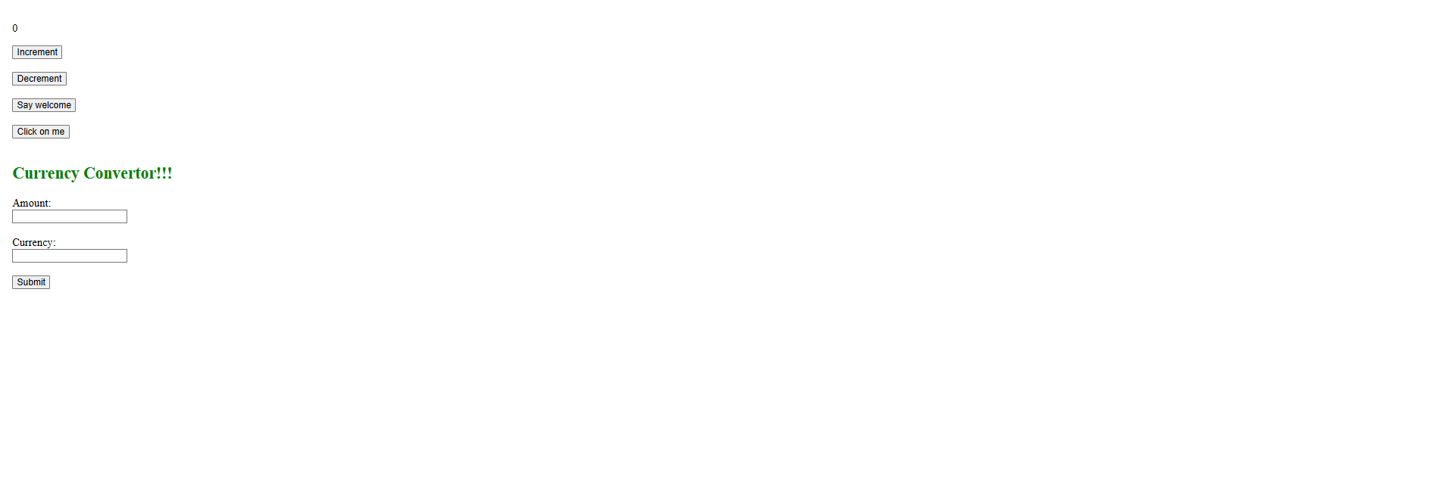

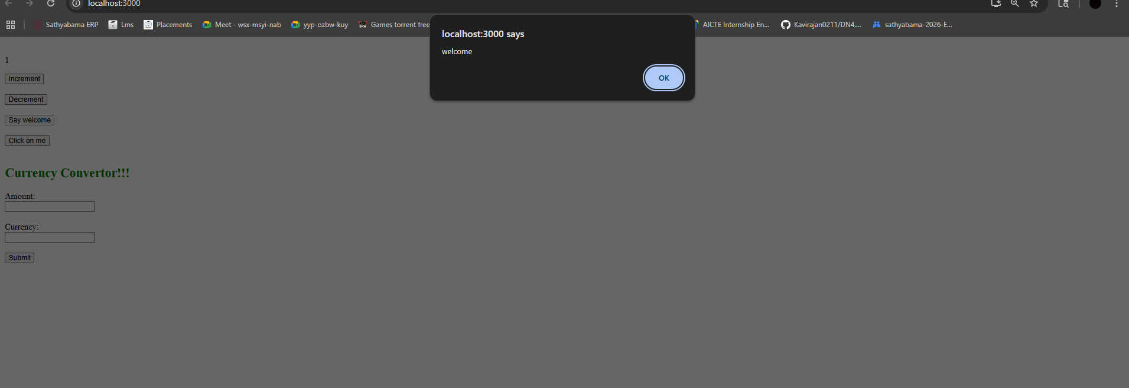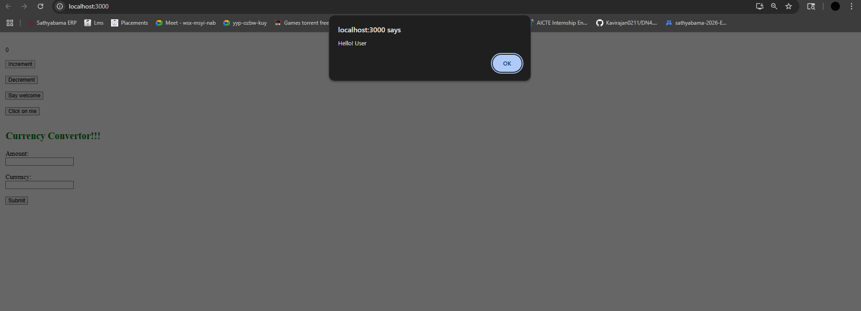

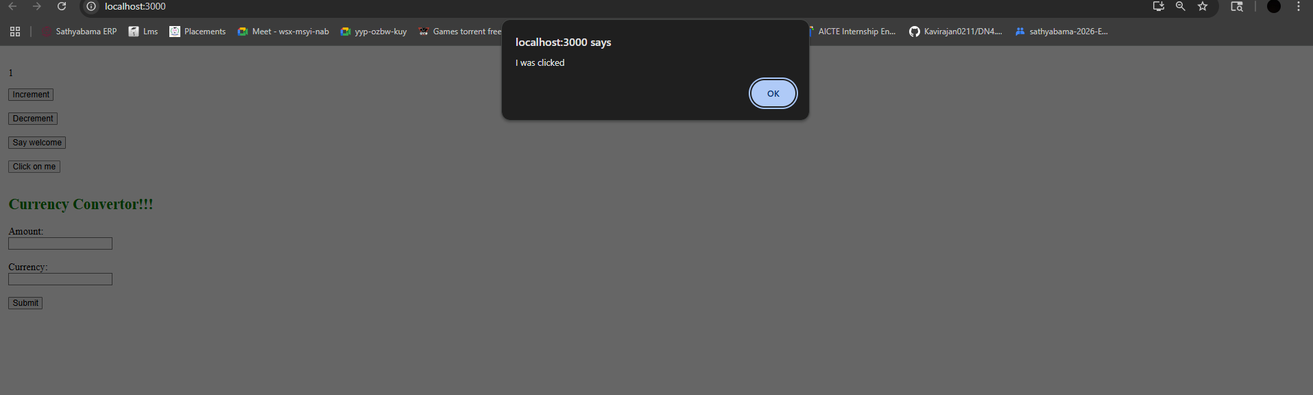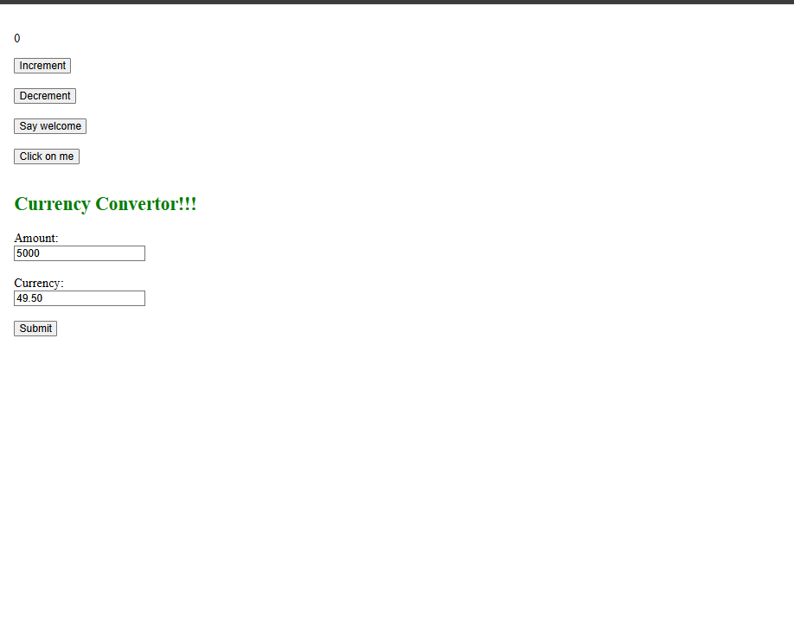

**ReactJS-HOL-12**

**App.js**

import React, { Component } from 'react';

class App extends Component {

  constructor() {

    super();

    this.state = {

      isLoggedIn: false

    };

  }

  login = () => {

    this.setState({ isLoggedIn: true });

  };

  logout = () => {

    this.setState({ isLoggedIn: false });

  };

  render() {

    let page;

    if (this.state.isLoggedIn) {

      page = (

        <div>

          <h2>Welcome User</h2>

          <p>You can now book your flight tickets.</p>

          <button onClick={this.logout}>Logout</button>

        </div>

      );

    } else {

      page = (

        <div>

          <h2>Welcome Guest</h2>

          <p>You can browse the flight details. Please login to book tickets.</p>

          <button onClick={this.login}>Login</button>

        </div>

      );

    }

    return (

      <div style={{ padding: '20px' }}>

        <h1>Flight Ticket Booking App</h1>

        {page}

      </div>

    );

  }

}

export default App;

**Output:**

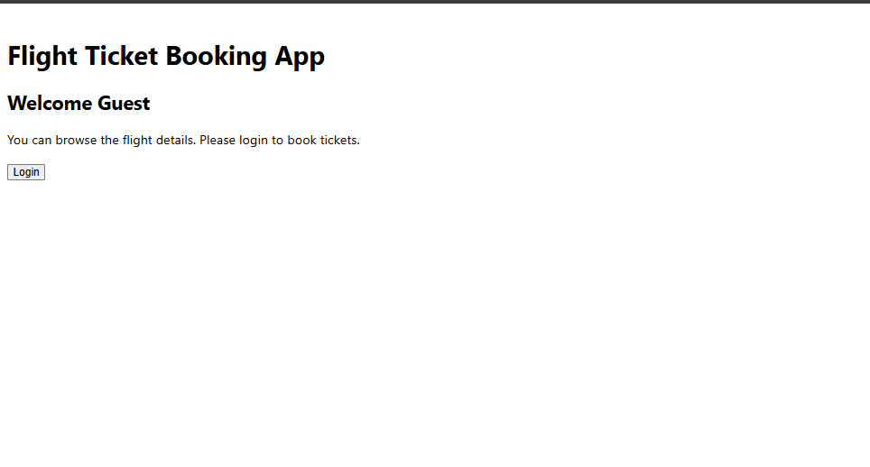

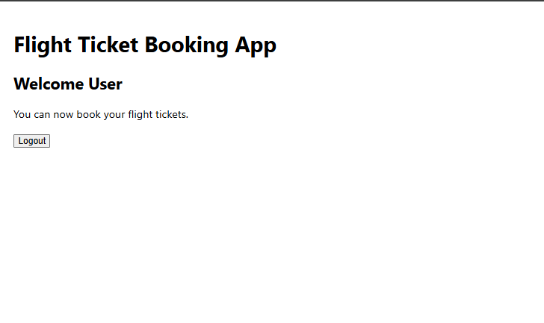

**ReacrJS-HOL-13**

**App.js**

import React, { Component } from 'react';

import CourseDetails from './CourseDetails';

import BookDetails from './BookDetails';

import BlogDetails from './BlogDetails';

class App extends Component {

  constructor() {

    super();

    this.state = {

      showAll: true

    };

  }

  render() {

    return (

      <div style={{ padding: '20px' }}>

        <h1 style={{ textAlign: 'center' }}>Blogger App</h1>

        {this.state.showAll && (

          <div style={{ display: 'flex', justifyContent: 'space-around' }}>

            <CourseDetails />

            <div style={{ borderLeft: '4px solid green', height: 'auto' }}></div>

            <BookDetails />

            <div style={{ borderLeft: '4px solid green', height: 'auto' }}></div>

            <BlogDetails />

          </div>

        )}

      </div>

    );

  }

}

export default App;

**BookDetails.js**

import React from 'react';

function BookDetails() {

  const books = [

    { title: "Master React", price: 670 },

    { title: "Deep Dive into Angular 11", price: 800 },

    { title: "Mongo Essentials", price: 450 }

  ];

  return (

    <div style={{ padding: '20px', textAlign: 'left' }}>

      <h2>Book Details</h2>

      {books.map((book, index) => (

        <div key={index}>

          <strong>{book.title}</strong><br />

          {book.price}

          <br /><br />

        </div>

      ))}

    </div>

  );

}

export default BookDetails;

**BlogDetails.js**

import React from 'react';

function BlogDetails() {

  const blogs = [

    {

      title: "React Learning",

      author: "Stephen Biz",

      content: "Welcome to learning React!"

    },

    {

      title: "Installation",

      author: "Schwezdenier",

      content: "You can install React from npm."

    }

  ];

  return (

    <div style={{ padding: '20px', textAlign: 'left' }}>

      <h2>Blog Details</h2>

      {blogs.map((blog, index) => (

        <div key={index}>

          <strong>{blog.title}</strong><br />

          <b>{blog.author}</b><br />

          <p>{blog.content}</p>

        </div>

      ))}

    </div>

  );

}

export default BlogDetails;

**CourseDetails.js**

import React from 'react';

function CourseDetails() {

  const courses = [

    { name: "Angular", date: "4/5/2021" },

    { name: "React", date: "6/3/20201" }

  ];

  return (

    <div style={{ padding: '20px', textAlign: 'left' }}>

      <h2>Course Details</h2>

      {courses.map((course, index) => (

        <div key={index}>

          <h4>{course.name}</h4>

          <p>{course.date}</p>

        </div>

      ))}

    </div>

  );

}

export default CourseDetails;

**Output:**

